Sdl core - qmlHMI demo编译及运行手顺
1. 安装必要的依赖包
sudo apt-get qtcreator
sudo apt-get update
sudo apt-get install build-essential
sudo apt-get install cmake
sudo apt-get install libudev-dev
sudo apt-get install libssl-dev
sudo apt-get install sqlite3 libsqlite3-dev
sudo apt-get install libavahi-client-dev
sudo apt-get install doxygen
sudo apt-get install libbluetooth-dev
sudo apt-get install git
sudo apt-get install qtdeclarative5-dev-tools
2、设置machine-id
sudo touch /etc/ machine-id
dbus-uuidgen
#记录 generated ID
sudo vim /etc/ machine-id
#将generated ID写入到文件中，保存退出
3、使用git下载代码
https://github.com/smartdevicelink/sdl_core.git

4、修改FindQt.sh文件
gedit src/FindQt.sh
位置：第102行
修改内容如下图红色框中内容相同
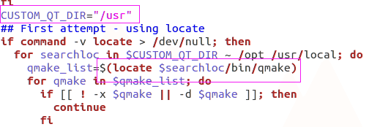

5、依次执行如下命令
cmake ./ -DEXTENDED_MEDIA_MODE=OFF -DHMI=qt -DHMI2=ON
make
make install
%cp bin/mykey.pem src/appMain
%cp bin/mycert.pem src/appMain

6、在终端中运行HMI
qmlscene -I ./src/components/qt_hmi/qml_model_qt5/ src/components/qt_hmi/qml_model_qt5/MainWindow.qml
7、重新打开一个终端，进入到<project_root>目录下运行sdl core
cd /src/appMain
./smartDeviceLinkCore

